📘 Theory of Computation (TOC) – Minor-2 Notes USICT GGSIPU | Exam Date: 01-05-2025

1. Turing Machines
- Definition: A Turing Machine (TM) is a 7-tuple (Q, Sigma, Gamma, delta, q0, q_accept, q_reject).
- Design: Infinite tape, read/write head, finite control.
- Example: TM for L = {a^n b^n | n ≥ 1}.
- Extensions:
  - Multi-tape TM
  - Non-deterministic TM
  - Stay-put TM
- Church–Turing Thesis: All algorithmically solvable problems can be solved by TM.

2. Recursive and Recursively Enumerable Languages
- Recursive (Decidable): TM halts for all inputs.
- Recursively Enumerable (RE): TM halts for valid inputs; may loop on invalid ones.
- Closure Properties:
  - Recursive: Union, Intersection, Complement
  - RE: Union, Intersection (not Complement)

3. Halting Problem
- Definition: Whether a TM halts on a given input.
- Result: Undecidable using contradiction (diagonalization).

4. Rice’s Theorem & Recursion Theorem
- Rice’s Theorem: All non-trivial properties of TM languages are undecidable.
- Recursion Theorem: TM can refer to its own description (used in self-replicating code/quines).

5. Complexity Classes
- P: Problems solvable in polynomial time.
- NP: Problems verifiable in polynomial time.
- co-NP: Complements of NP problems.
- PSPACE: Polynomial space solvable problems.
- NPSPACE: Equal to PSPACE (Savitch’s Theorem).

6. Polynomial Time Reductions, NP-Completeness & NP-Hardness
- Reduction (≤p): Solving one problem using another in polynomial time.
- NP-Complete: In NP + every NP problem reduces to it.
  - Examples: SAT, 3-SAT, Clique, Vertex Cover.
- NP-Hard: As hard as NP-complete; not necessarily in NP.
  - Examples: Halting Problem, Tiling Problem.

Notes-YouTube

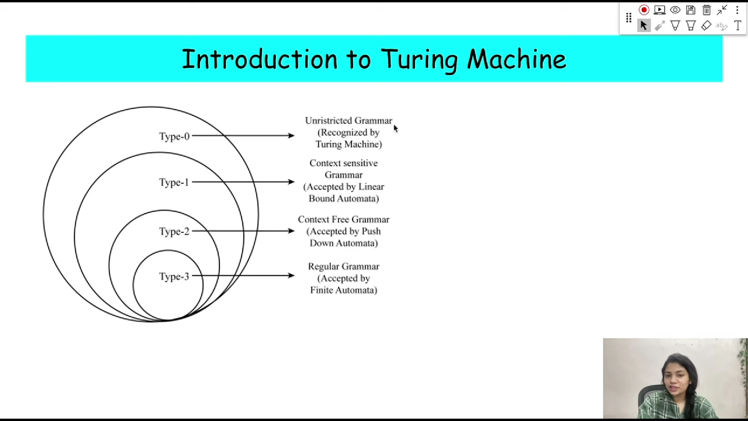

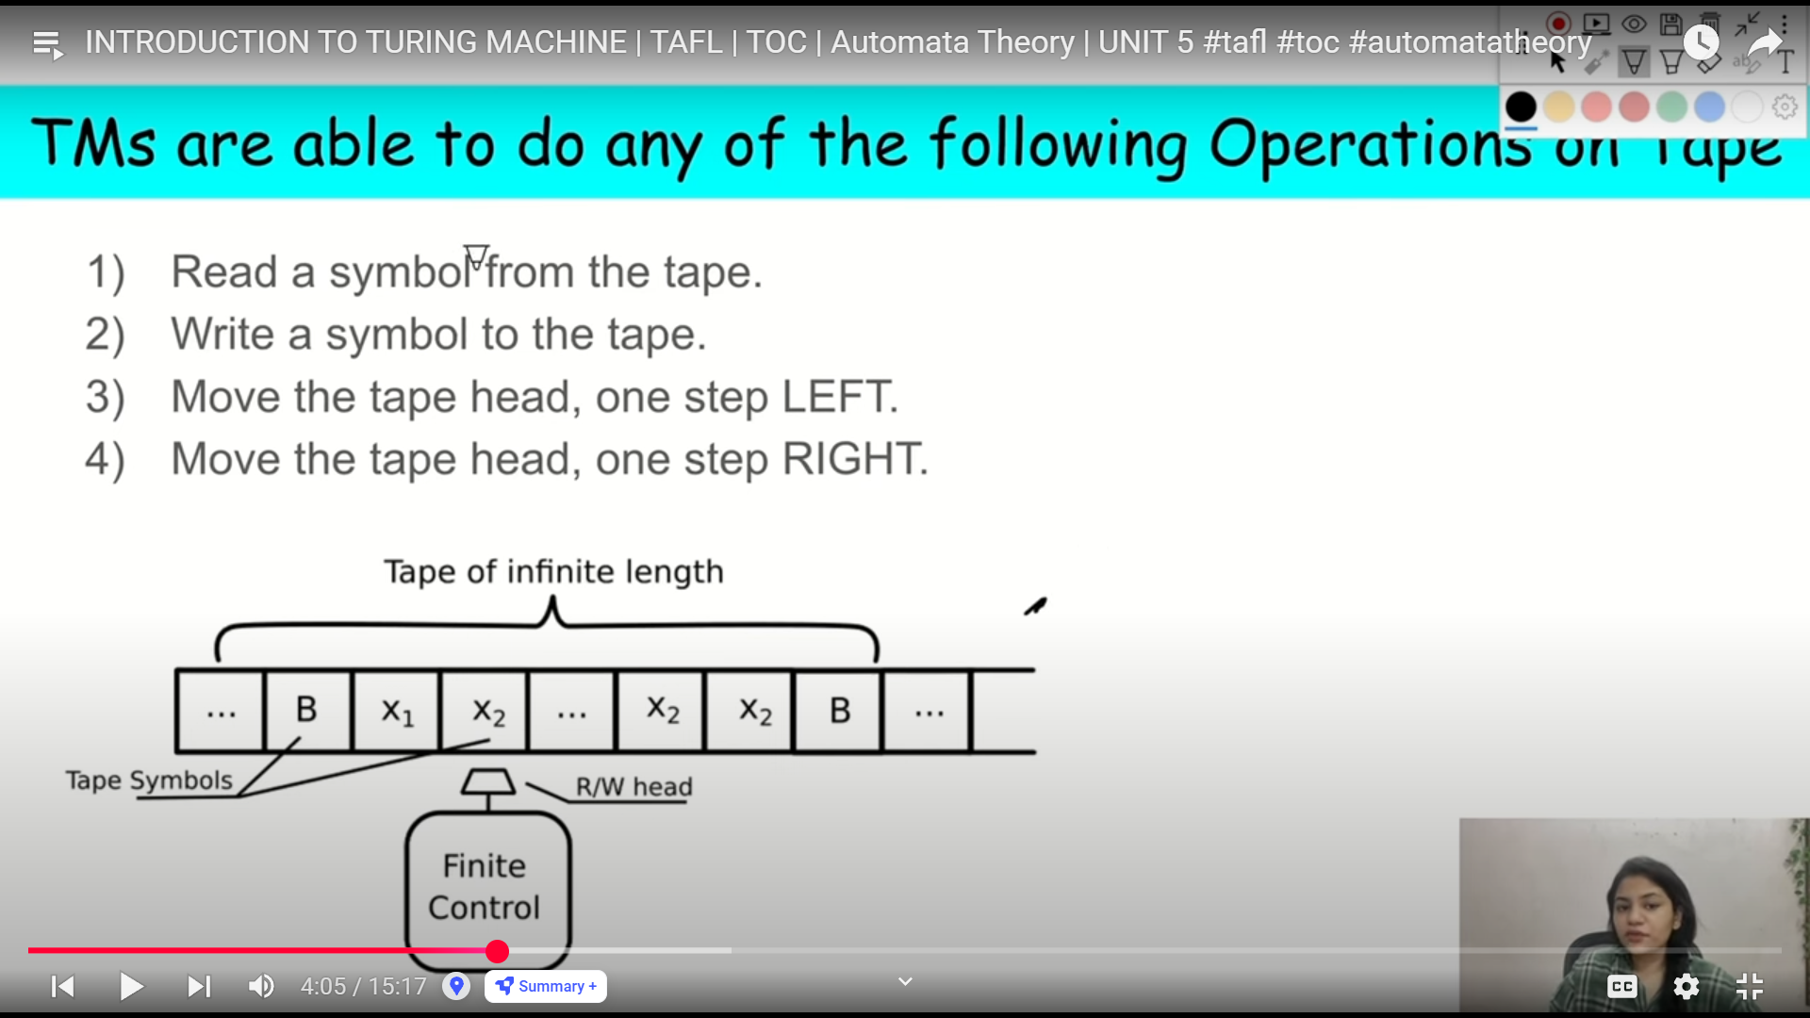

Q: Is the Turing Machine tape infinite in both directions?
A: No, the standard Turing Machine tape is infinite only in one direction (usually to the right). However, there is a variant of the Turing Machine with a doubly infinite tape (infinite in both directions), but it is not more powerful than the standard one in terms of computational power.

Q: What does the Church–Turing Thesis state?
A: The Church–Turing Thesis states that any function that is computable by an algorithm can also be computed by a Turing Machine.

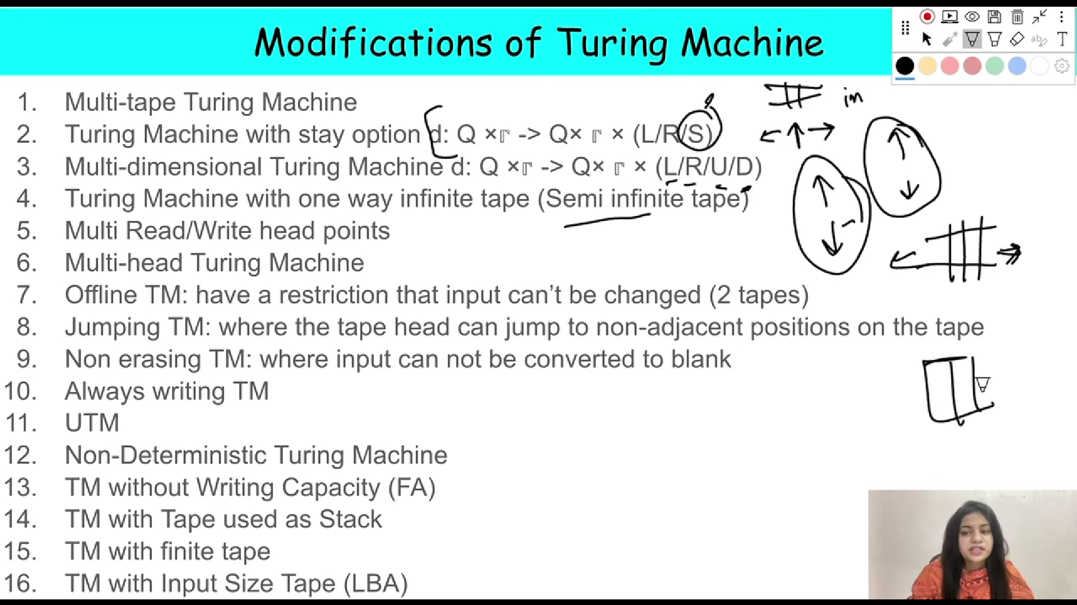

🧠 Q1: What is a Deterministic Turing Machine (DTM)?
A: A DTM is a Turing Machine where for each state and input symbol, there is exactly one transition.
➡️ One path of execution only.
➡️ Works in a predictable and fixed manner.

🤖 Q2: What is a Non-Deterministic Turing Machine (NDTM)?
A: An NDTM is a Turing Machine where for some state and input symbol, there may be multiple possible transitions.
➡️ Can explore many computation paths in parallel (theoretically).
➡️ Accepts input if any path leads to acceptance.
📌 Note: NDTM and DTM have the same power (they accept the same class of languages).

🌐 Q3: What is a Universal Turing Machine (UTM)?
A: A Universal Turing Machine is a Turing Machine that can simulate any other Turing Machine.
➡️ It takes as input the description of another Turing Machine and an input string, and simulates the behavior of that machine on that input.
➡️ Key idea behind modern computers — they can run any algorithm if programmed correctly.
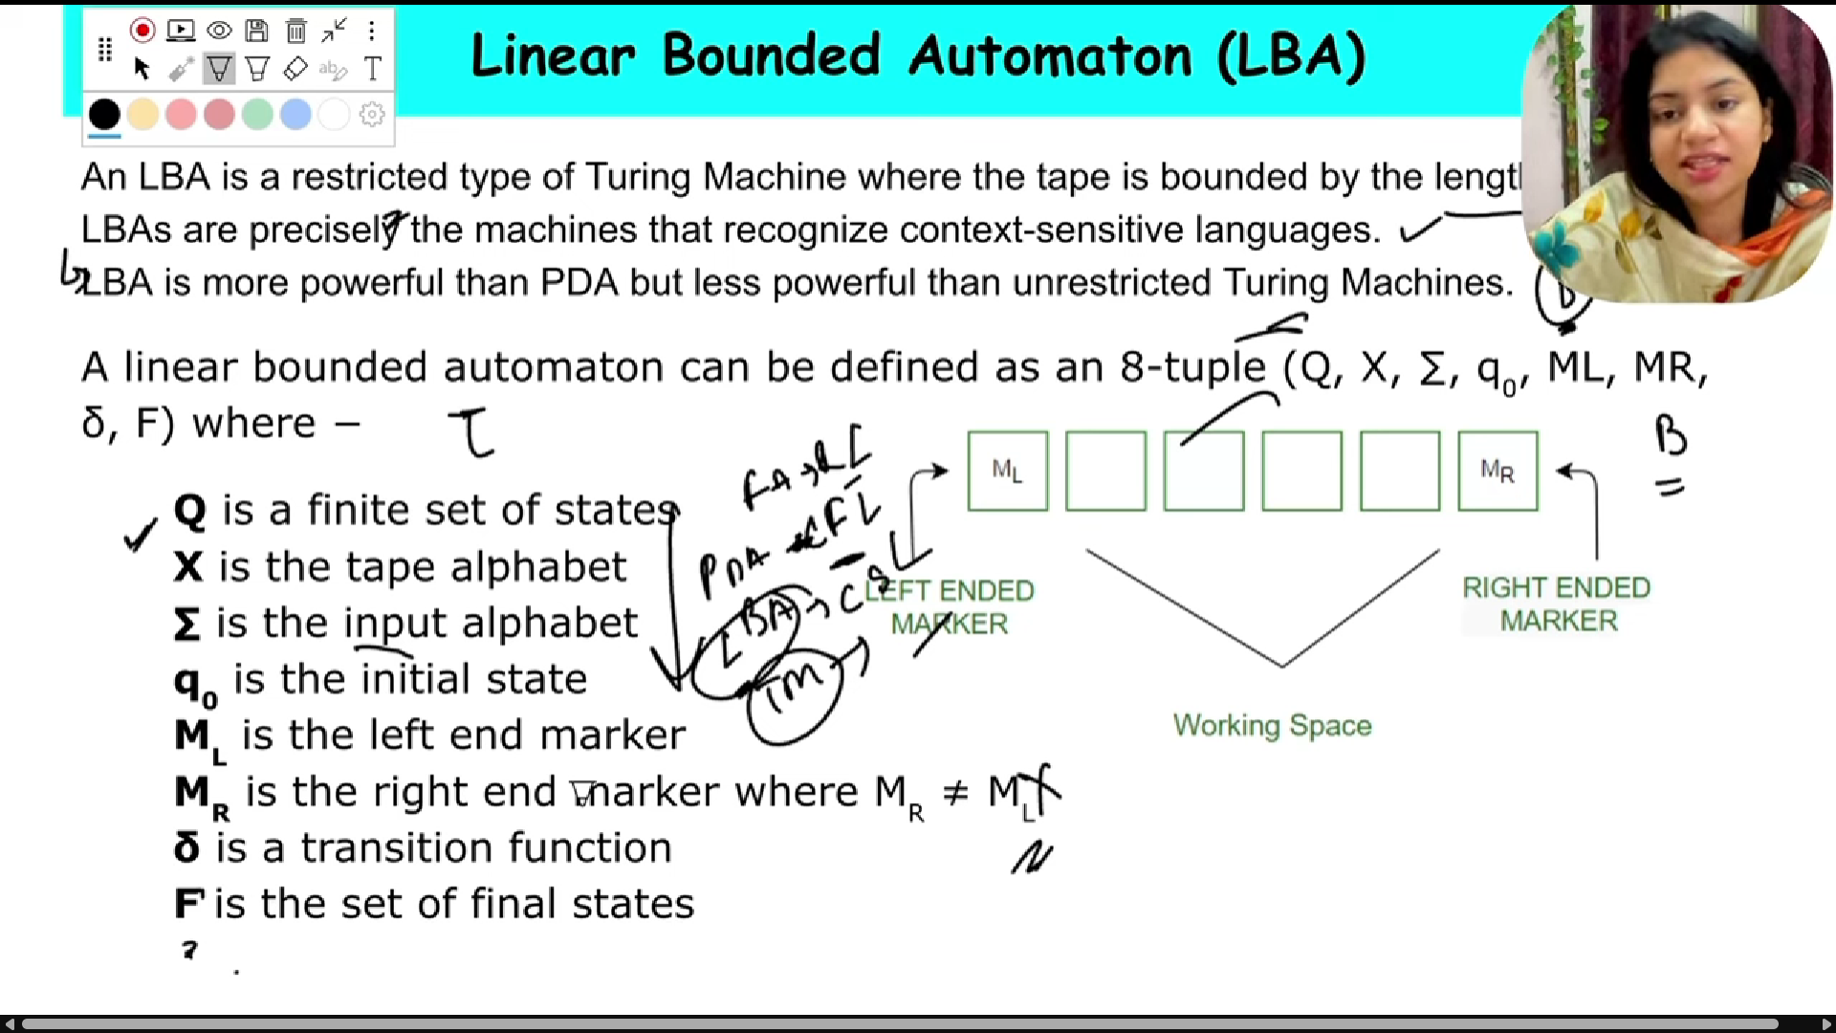
USICT GGSIPU ke syllabus ke hisaab se (jo tune diya hai), usme "Universal Turing Machine (UTM)" directly mentioned nahi hai.

📌 Kya Universal TM padhna zaruri hai?
Answer: Directly nahi, lekin indirectly useful ho sakta hai — kyunki:
- Halting Problem aur Rice’s Theorem me UTM ka concept background me use hota hai.
- Agar theoretical MCQ ya assertion-reason type questions aaye, toh UTM ka basic idea helpful hoga.

🔍 Toh bas itna padhna kaafi hoga UTM ke liye:

✅ Universal Turing Machine (UTM) – Basic Idea
- Definition:
A Universal Turing Machine is a TM that can simulate any other TM on arbitrary input.
- Motive:
Just like a general-purpose computer, UTM can take as input:
  - Description of a Turing Machine M
  - Input w to that TM
And simulate the behavior of M on w.
- Symbolically:
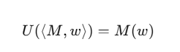
- Why Important?
  - Proves that a single TM can be programmed to perform any computation — just like today’s computers.
  - Core idea behind Halting Problem proof.

📚 Exam Relevance:
Topic | UTM Usefulness
Turing Machines | Not directly
Halting Problem | 🔥 Yes, used in proof
Rice's Theorem | 🔥 Yes, indirectly
Recursion Theorem | Slightly
Complexity Classes | ❌ Not used

🧠 So Final Verdict:
UTM ka detailed design ya working yaad karne ki zarurat nahi hai, bas itna concept yaad rakho:
“Universal TM ek aisi machine hai jo kisi bhi Turing Machine ko simulate kar sakti hai.”
Bilkul bhai! Halting Problem ka proof important hai — aur haan, exam me aa sakta hai in these forms:
- “Explain Halting Problem with proof.”
- “Prove that the Halting Problem is undecidable.”
- “Is Halting Problem recursively enumerable?”
So haan, ye zarur padhna chahiye.

✅ Halting Problem – Full Proof (with Explanation)
📚 Precise Proof (Same as Uploaded Solution):

Halting Problem:
Given a Turing Machine M and input w, decide whether M halts on w.
Language:
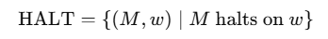

Proof:
Assume: There exists a Turing Machine HHH which decides HALT.
- Input to H: (M, w)
- Output:
  - YES → if M halts on w
  - NO → if M does not halt on w

Construct a Machine H′ using H:
- Input: (M, w)
- Working:
  - If H outputs YES → Loop forever
  - If H outputs NO → Halt immediately
(Thus, H′′ does the opposite behaviour of H.)

Now Construct Machine H cap:
- Input: M
- Working:
  - Run H′ on input (M, M)
(i.e., Machine MMM with its own description as input.)

Now run H^ on input H^ itself:
- Input: H^
- Working:
  - H′ will be given (H^,H^)
  - Two cases arise:
    - If H^ halts on H^→ H ′ will loop forever → contradiction.
    - If H^ does not halt on H^ → H ′ halts → contradiction.
Thus, contradiction occurs in both cases.

Conclusion:
Hence, no such machine HHH can exist.
Therefore, the Halting Problem is Undecidable.

🧠 Final Mapping:
Machine | Meaning
H | Assumed decider for HALT
H′ | Modified machine (opposite behaviour of H)
H^ | Final machine to create contradiction

✅ Proof is exactly according to your uploaded solution.
✅ Short, exam-ready, same logic flow (H → H' → Ĥ).
✅ Real standard explanation.

📝 Short Answer (1-2 lines):
The Halting Problem is undecidable.
This is proven by contradiction, assuming a decider H exists, constructing D that leads to paradox on input D(D).

